Practice basic bash, IO redirection, pipe, file and directory operations, searching files, process management and vi/nano editor commands

1.whoami 🡪 Display the usename

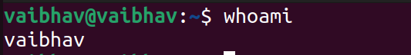

2.hostname 🡪 Displays the hostname

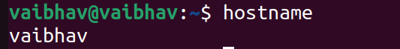

3.ls 🡪 Displays the list of directories



4.ls -la 🡪 Displays the list of directories including hidden files and other details

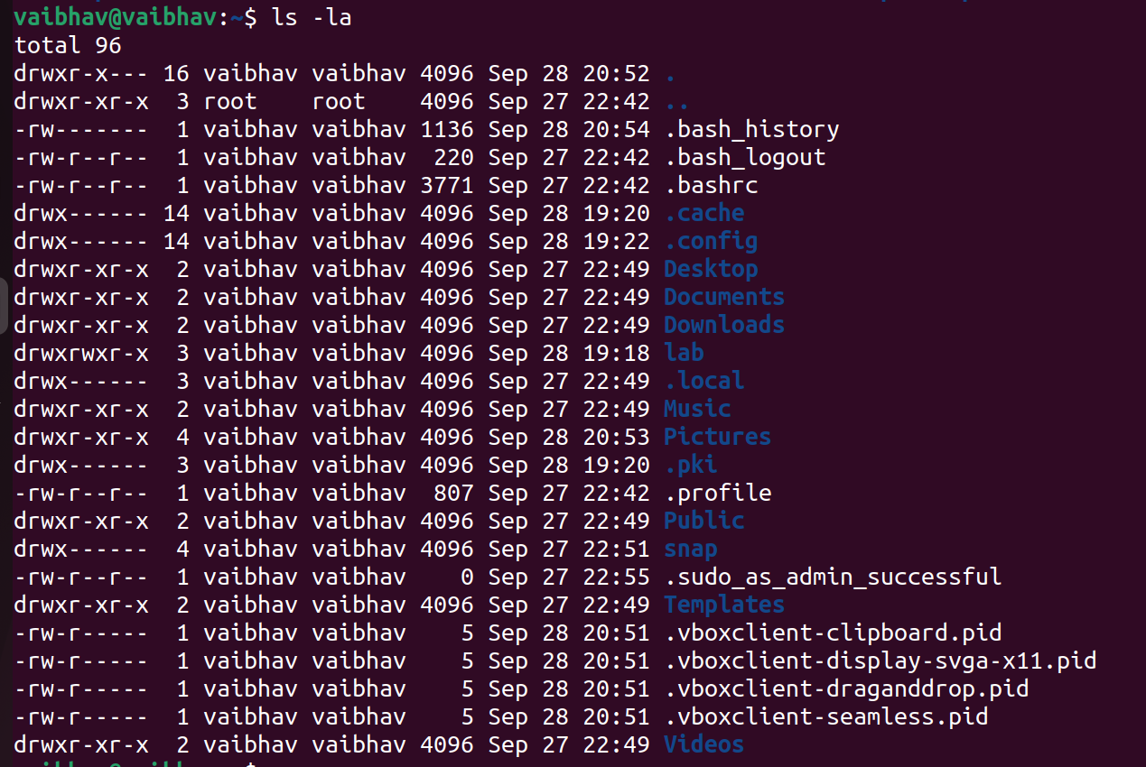

5.pwd 🡪 Displays the current working directory

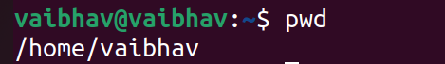

6.cd <dir name> 🡪 To access the directory

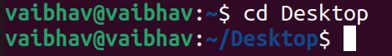

7.cd 🡪 To go back to the previous directory

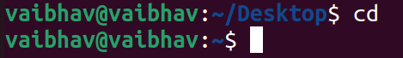

8.cd 🡪 To go to home directory

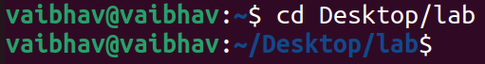

9. cd <path> 🡪 To open a particular directory using path



10. touch <filename> 🡪 To create a file

11. touch <filename>{from..to} 🡪 To create multiple files instantly

12. vi/nano <filename> 🡪 Creates a file and open in write mode



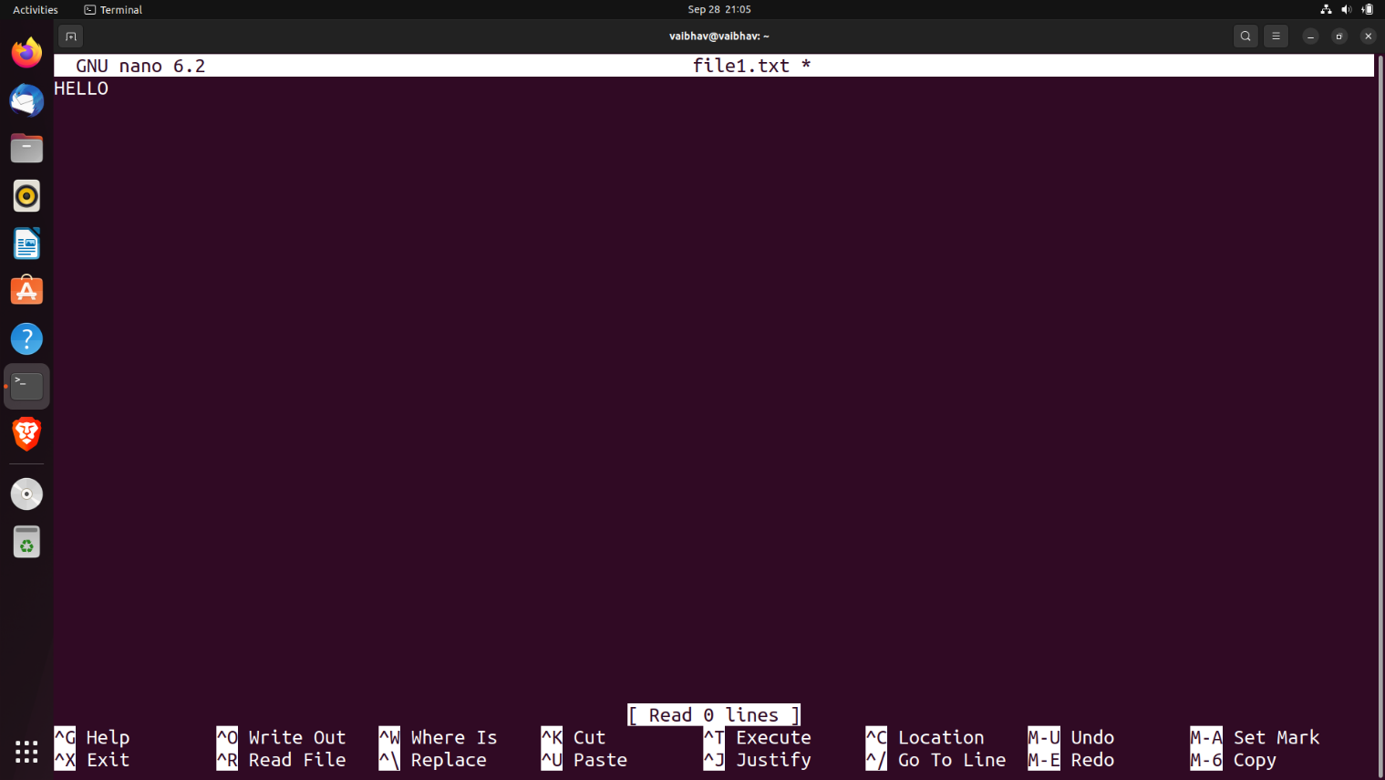

13. cat <filename> 🡪 Displays the content in the file



14. mkdir <dirname> 🡪 Creates a directory

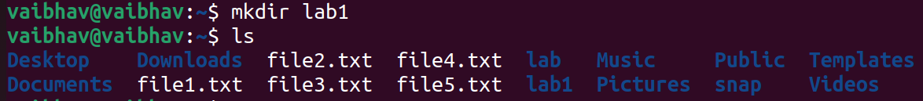

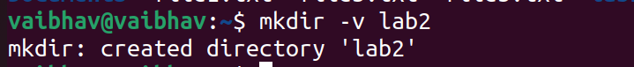15. mkdir -v <dirname> 🡪 Creates a directory and displays the status

16. mkdir -p <dirname/dirname2> 🡪 Creates a directory within a directory

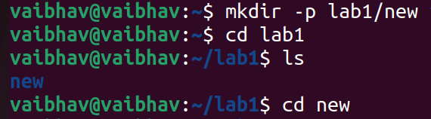

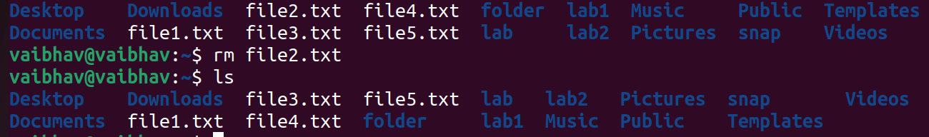17. rm <filename> 🡪 To remove/delete a file

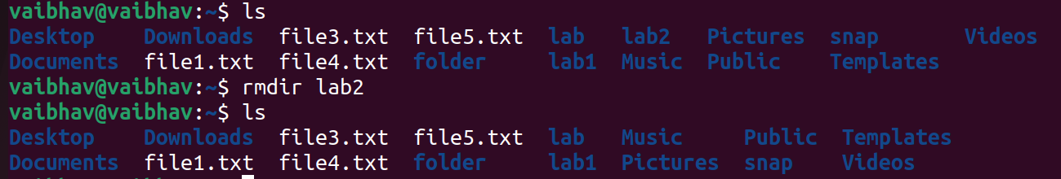18. rmdir < dirname> 🡪 To remove/delete a directory

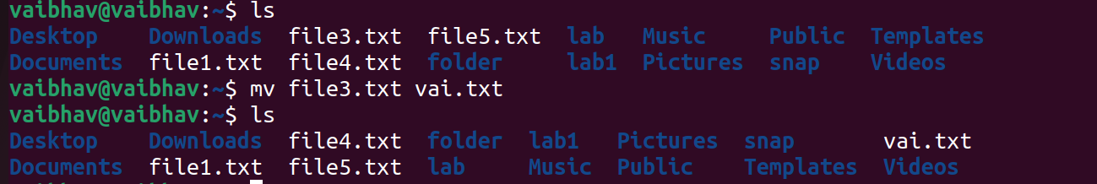19. mv <filename> <newname> 🡪 To rename a file

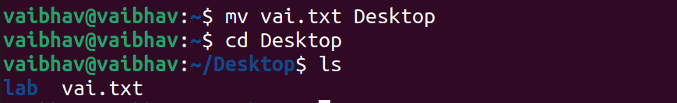20. mv <filename> <path> 🡪 To move a file from a directory to a specified directory

21. mv -i <filename <path> 🡪 To move a file and ask permission to overwrite if file already exists

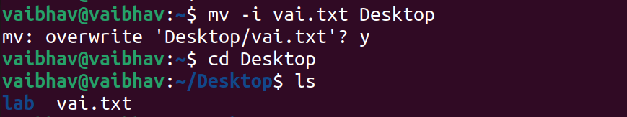

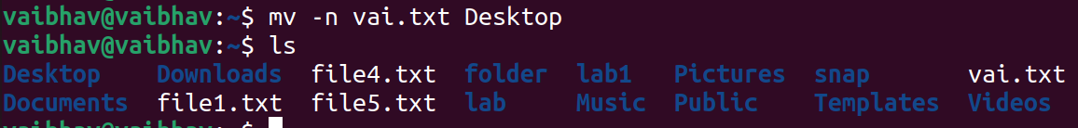22. mv -n <filename <path> 🡪 To move a file and deny permission to overwrite if file already exists

23. mv -b <filename <path> 🡪 To move a file and create a backup of the old file

